NAME: AKSHATA VERMA
REG. NO.: RA1911003010309
SECTION: E1

Exp.No1 Toy Problem

TIC TAC TOE AI PROBLEM

Source code in C++

#include <stdio.h>

#include <stdlib.h>

#include <iostream>

using namespace std;

char matrix[3][3]; //intitial matrix declaration

char check(void); // declaration of functions

void init_matrix(void);

void get_player_move(void);

void get_computer_move(void);

void disp_matrix(void);

int main(void)

{

char done;

cout<<"Human vs. AI Tic Tac Toe."<<endl;

cout<<"You will be playing against the computer as 'X'"<<endl;

done = ' ';

init_matrix();

do {

disp_matrix();

get_player_move();

done = check(); /* check winner */

if(done!= ' ') break; /* if winner found...*/

get_computer_move();

done = check(); /* check for winner again */

} while(done== ' ');

if(done=='X')

cout<<"Human won! (but AI very dumb anyway)\n";

else

cout<<"AI so stupid still can win against you..."<<endl;

disp_matrix(); /* show final positions */

return 0;

}

/*Functions and function prototypes below

==============================================================================*/

void init_matrix(void) //matrix intitialisation

{

int i, j;

for(i=0; i<3; i++)

for(j=0; j<3; j++) matrix[i][j] = ' ';

}

void get_player_move(void) //call function for player input

{

int x, y;

cout<<"Enter X,Y coordinates for your move: ";

// scanf("%d%*c%d", &x, &y);

cin >> x >> y;

x--; y--;

if(matrix[x][y]!= ' '){

cout<<"Invalid move, try again.\n";

get_player_move();

}

else matrix[x][y] = 'X';

}

void get_computer_move(void) //AI move input

{

int i, j;

for(i=0; i<3; i++){

for(j=0; j<3; j++)

if(matrix[i][j]==' ') break;

if(matrix[i][j]==' ') break;

}

if(i*j==9) {

cout<<"draw\n";

exit(0);

}

else

matrix[i][j] = 'O';

}

void disp_matrix(void) //matrix display

{

int t;

for(t=0; t<3; t++)

{

// printf(" %c | %c | %c ",matrix[t][0],

// matrix[t][1], matrix [t][2]);

cout << " " << matrix[t][0] << " | " << matrix[t][1] << " | " << matrix[t][2] << " ";

if(t!=2)

// printf("\n---|---|---\n");

cout << "\n---|---|---\n";

}

// printf("\n");

cout << "\n";

}

char check(void) //used for identifying winner

{

int i;

for(i=0; i<3; i++) /* check rows */

if(matrix[i][0]==matrix[i][1] &&

matrix[i][0]==matrix[i][2]) return matrix[i][0];

for(i=0; i<3; i++) /* check columns */

if(matrix[0][i]==matrix[1][i] &&

matrix[0][i]==matrix[2][i]) return matrix[0][i];

/* test diagonals */

if(matrix[0][0]==matrix[1][1] &&

matrix[1][1]==matrix[2][2])

return matrix[0][0];

if(matrix[0][2]==matrix[1][1] &&

matrix[1][1]==matrix[2][0])

return matrix[0][2];

return ' ';

}

OUTPUT:

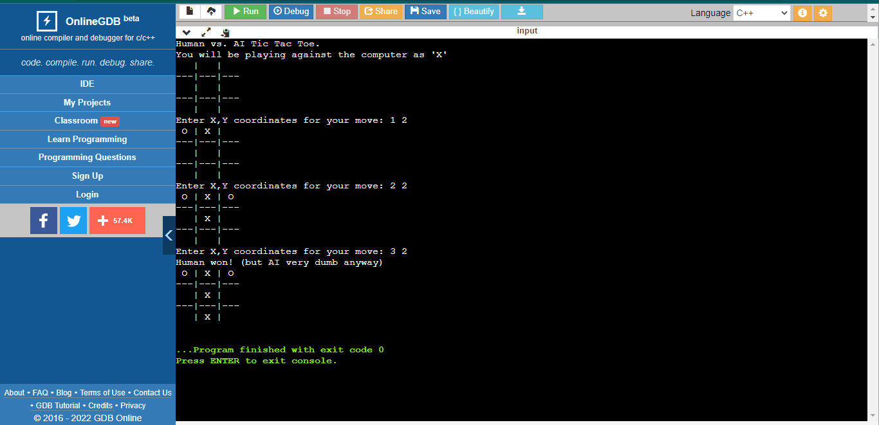

N QUEENS PROBLEM

Source code in Python

def is_attack(i, j, board, N):

# checking for column j

for k in range(1, i):

if(board[k][j] == 1):

return True

# checking upper right diagonal

k = i-1

l = j+1

while (k>=1 and l<=N):

if (board[k][l] == 1):

return True

k=k+1

l=l+1

# checking upper left diagonal

k = i-1

l = j-1

while (k>=1 and l>=1):

if (board[k][l] == 1):

return True

k=k-1

l=l-1

return False

def n_queen(row, n, N, board):

if (n==0):

return True

for j in range(1, N+1):

if(not(is_attack(row, j, board, N))):

board[row][j] = 1

if (n_queen(row+1, n-1, N, board)):

return True

board[row][j] = 0 #backtracking

return False

if __name__ == '__main__':

board = [[0,0,0,0,0],[0,0,0,0,0],[0,0,0,0,0],[0,0,0,0,0],[0,0,0,0,0]]

n_queen(1, 4, 4, board)

#printing the matix

for i in range(1, 5):

print(board[i][1:])

OUTPUT:

